1.INTRODUCTION

Campus Placements/ Campus Recruitment drives are conducted in various educational institutes for providing job opportunities to the students. Campus Recruitment allows students to earn a safe and secure future. Keeping in mind the importance of the placement, it is vital for a student to prepare adequately for these programs and ensure that they put their best foot forward.

2.OVERVIEW

We are sure you all will be aware of what is campus interview is. But, are you well informed about the type of campus placement?

In general, there are mainly two types of campus placements that can be classified under the existing campus placement models. They are:

On-Campus Placement:

In On-Campus placement drives, recruitment companies are officially invited on the college campus to conduct interviews to gauge their potential as future employees. The placement process is centralized. Before the interviews, they make a selection on criteria like student’s knowledge, technical abilities, and zeal to work.

Off-Campus Placement:

As the name defines, it is a type of placement conducted outside the college campus. In Off-campus placement, the role of college is absent. This means that there are no rules and regulations of the college, and seek employment on your own. Reputed companies conduct pool placement interviews where students from different colleges assemble at a commonplace.

Students who have failed to get an on-campus placement can get a career opportunity through this type of placement. Here, an individual need to take a lot of effort to find their perfect employment fit.

Pool Campus Placement:

This type of campus placement considers a specific affiliation criterion. The concept of the pool campus placement enables a student to attend campus interviews held at colleges that are affiliated with the same university. Pool Placements adds an advantage for the students of the colleges to join the combined placement drives, which are similar to on-campus drives with a larger scale. Here, one gets to explore a lot of career choices to opt for.

On-Campus Vs. Off-Campus Vs. Pool Campus Placement

The ultimate purpose of the placement drives is to hire candidates that fit the organization’s requirements. However, every college campus recruitment has its own pros and cons.

If you talk about on-campus vs. off-campus recruitment drives, on-campus placement focuses on saving your time, provides you limited competition that increases the higher success probabilities, dedicated assistance from the respective college placement team that guarantees placement. Whereas, in off-campus recruitment, one gets to explore an infinite range of opportunities without any interference from the college and feel a sense of self-achievement after getting placed. Apart from pros, off-campus has a few cons, like facing more challenges during the placement process and limited career prospects. Pool campus placement paves the way for creating larger talent; therefore, there are higher chances for selection. As this approach encourages the participation of a number of colleges and students, it brings diversity to the company as a whole. On the other side, Pool campus placement involves a large number of participants, which makes appropriate evaluation of the real talent difficult. So, this approach requires detailed planning and precision to manage this placement process efficiently

3.PURPOSE

* To identify the talented and qualified students in the college.
* To create promising career opportunities for students in reputed corporate companies.
* To select candidates who are suitable for the current job roles without any biased behaviour.
* To provide roles and duties as per the student’s knowledge, expertise, and interest.
* To ensure students start a career and move forward in the right direction for better quality living.
* To provide ultimate satisfaction to students by offering the companies of their choice according
* to their eligibility.
* To provide career guidance through counselling and interactions with industry experts.
* To evaluate and select the right candidate to meet the organization’s requirements.
* To identify the professional traits, real-time skills, and values within the students.

4.PROBLEM DEFINITION & DESIGN THINKING

EMPATHY MAP



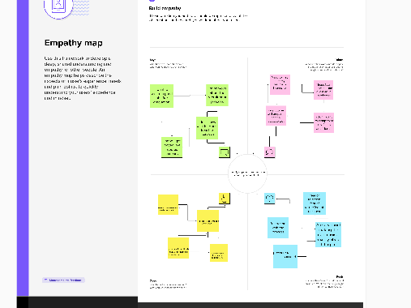

4.1IDEATION &BRAINSTORMING MAP



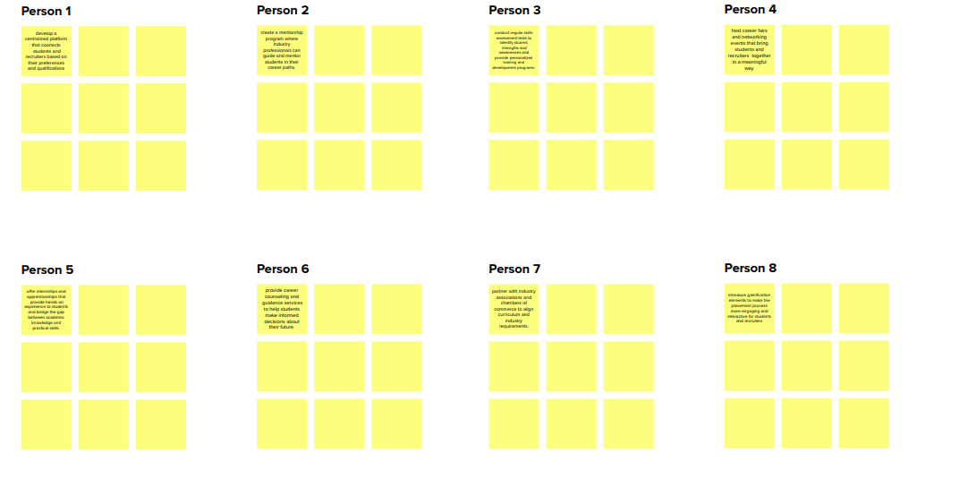

5.RESULT

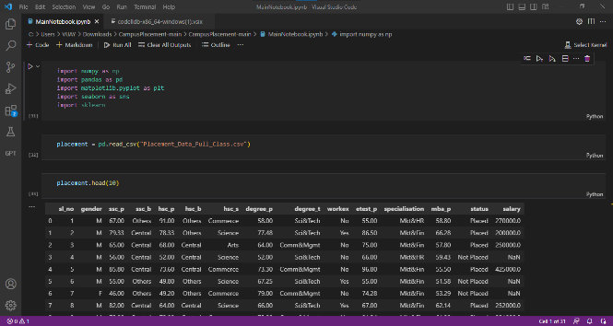

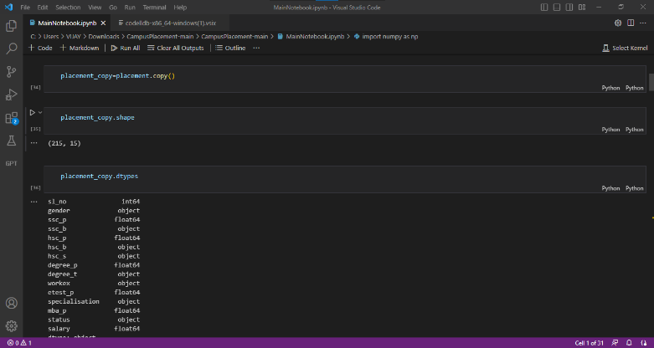

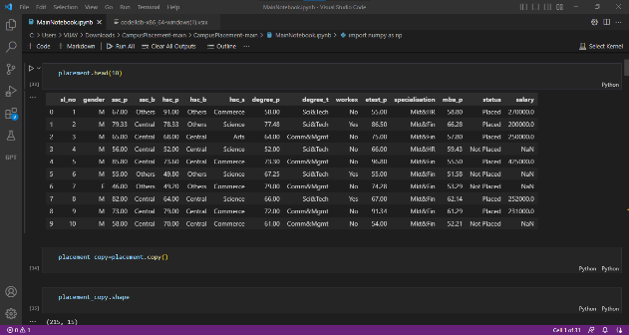

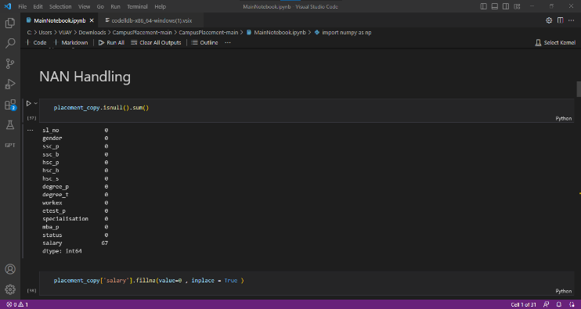

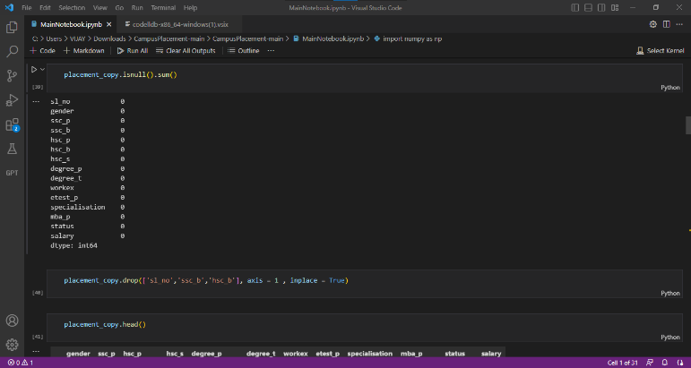

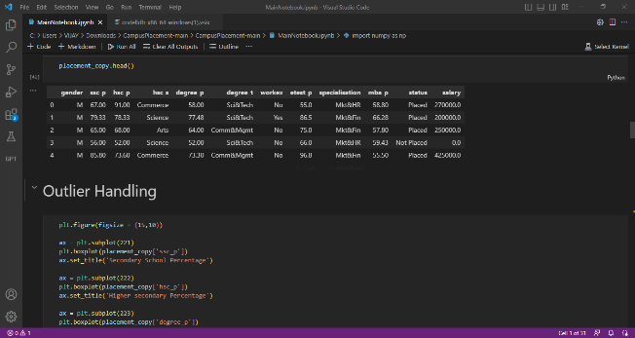

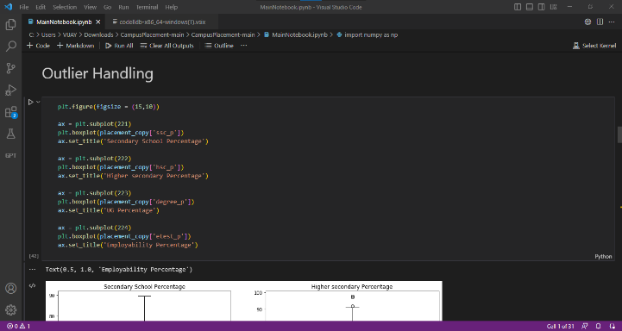

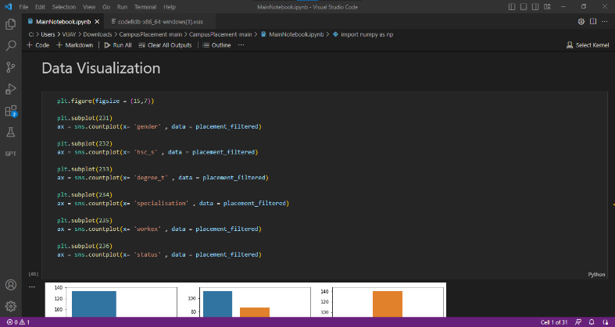

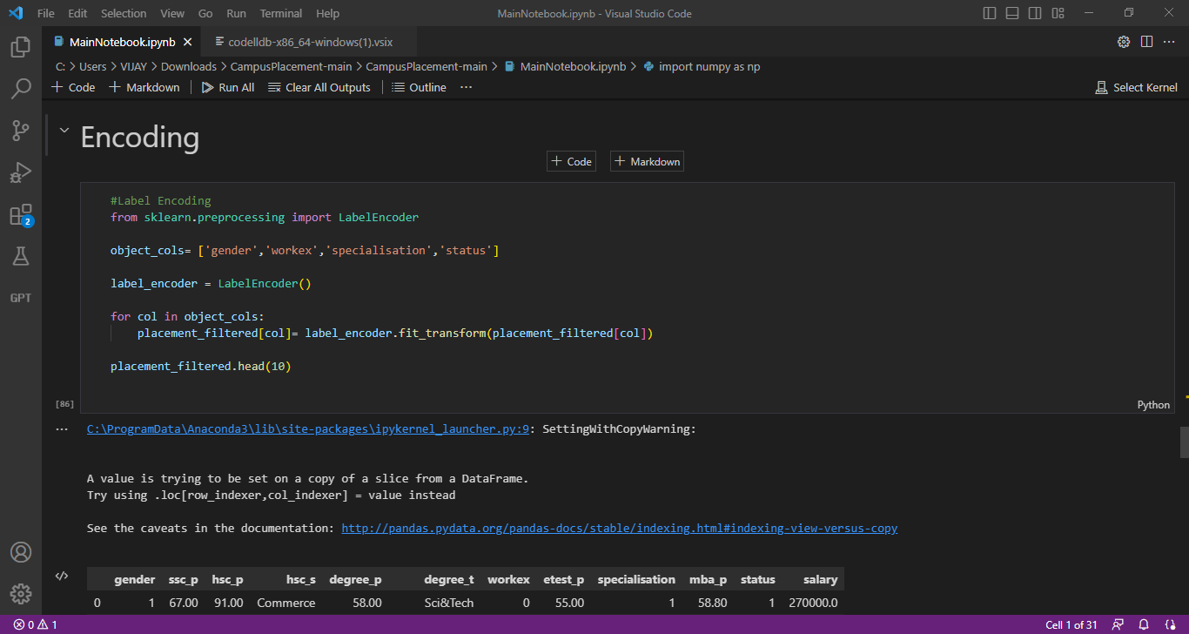

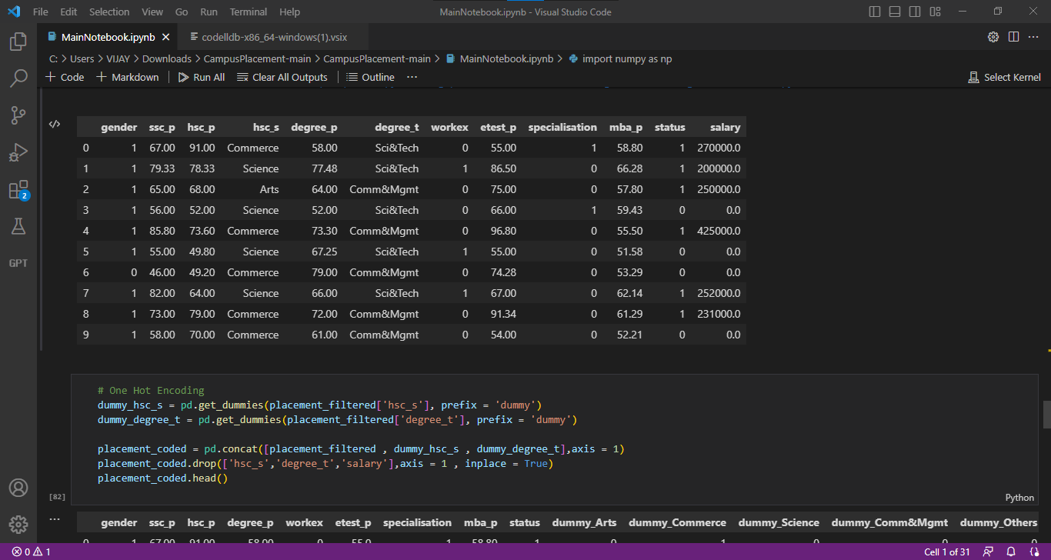

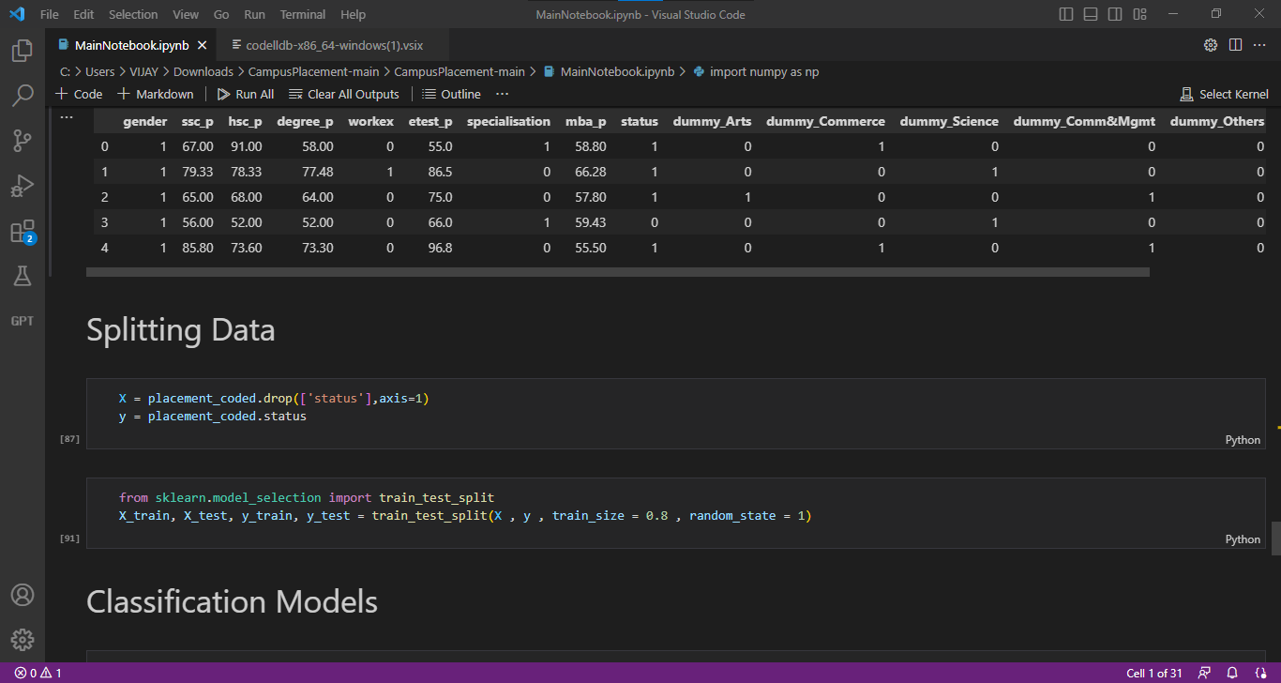

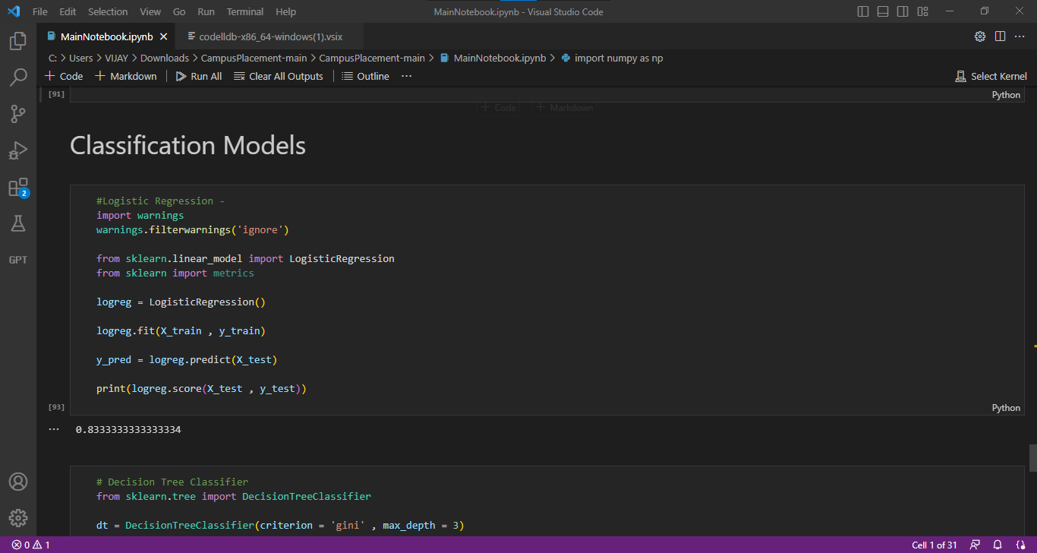



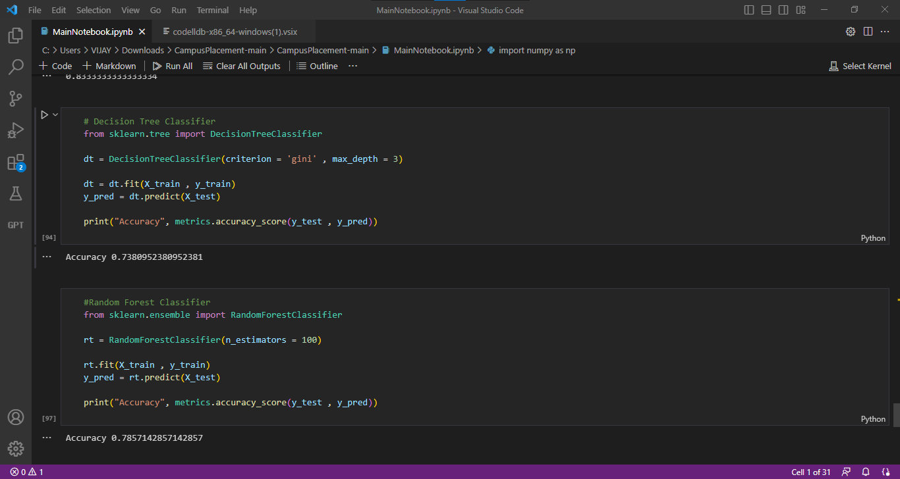

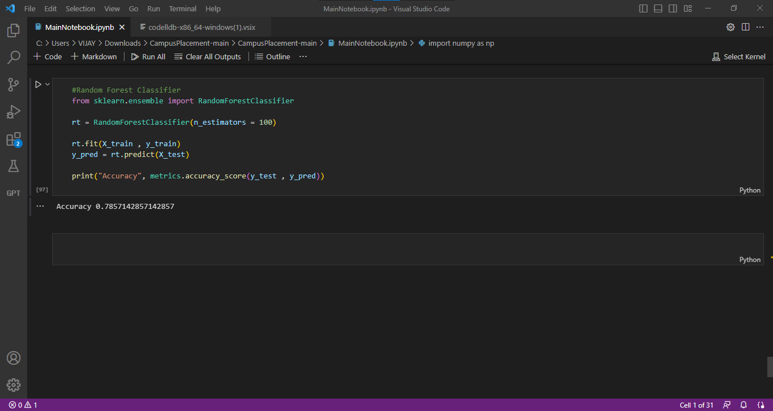

6.ADVANTAGES &DISADVANTAGES

ADVANTAGES:

1. A student who get’s recruited in Campus would have saved time, Even before completing their degree they getting recruited that is lot’s of Time saved.

2. A Students finishes Degree in a happy mood as they have bagged a Job. They do not have to think about the job search strategies

3. A student gets Top Branded Organizations and attracts good offers, Top MNC’s recruit students from collage and offer Good Salary Package.

4. A student who gets recruited during campus selection enjoy a better social status with the collages, class mates & family.

DISADVANTAGES:

1. Limited opportunities, assume if your collage invited 10 companies for campus selection then you are exposed to those 10 opportunities and if you are selected in campus then you had limited opportunities in front of you. but If you are not selected then you will search job in the open market then you would be having all companies in the domain as your opportunity.

2. If you are selected in campus then there are least chances for you to choose your special area of your interest. Assume if you are an Engineer and have dreams of making Career as IoT Developer then there are least chances you getting placed in special area of your interest in Campus.

3. Most of the Campus recruitments are conducted by big organizations like MNC’s, but small sector and startups companies offer an excellent growth and learning curve, if you want to get expertise in a specific area then startup helps building your career better than an MNC. MNC’s may provide a better salary and facilities but small companies and startup provide better projects & work experience and better foundation for your career. You may not get social status but you will be satisfied with your project & Work Experiences.

7.APPLICATIONS

1.network with companies

2.network with alumni

3.Personal development Training

4.industrial visits

5.online assessments

6.cooperate guest lectures

7.skill assessment tests 8.linkedln

8.CONCLUSION:

In this project, we utilize two powerful machine learning models - Random Forest and Decision Tree - to predict placements of engineering students. We apply various techniques such as outlier detection and removal, correlation analysis, and categorical variable encoding to preprocess the data and improve model performance. Additionally, we conduct in-depth data analysis and visualization to gain deeper insights into the data. Feel free to experiment with other models or tune hyperparameters to further enhance the model's accuracy. Let's dive in and keep exploring

9.FUTURE SCOPE:

1.social and mobile recruitment

2.talent optimization via AI

3.competitive Hiring

4.online applications

5.mobile recruiting

6.video interview

7.Digital Structured Interviews

10.APPENDIX:

